The photos show people showing others how to do things.
What might the activities involve?
How are the people feeling?
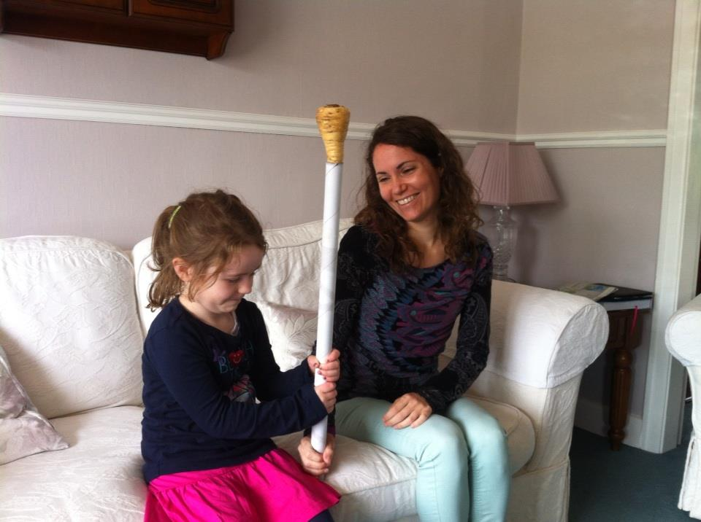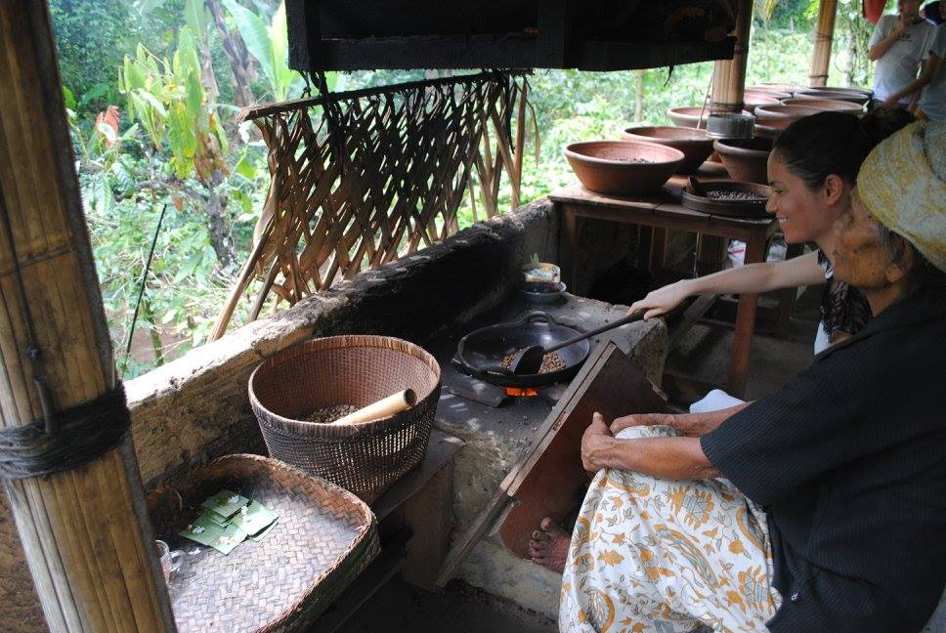
In the first picture it looks like there is a woman showing a young girl how to hold what seems to be a kind of pole, with a parsnip on top. I guess it´s some kind of bizarre game or tradition where you need to balance the parsnip without dropping it. In the second image, on the other hand, it looks as though a woman is being taught how to cook something in a giant wok, it could be beans or maybe coffee. This looks a fair bit more complicated than the task in the first image and the old lady doesn’t appear to be too impressed with the way the woman is stirring the beans, whereas the lady, in contrast, looks delighted with herself, judging by the expression on her face. Similarly, in the first picture the lady gives the impression of being over the moon with how the little girl is managing to hold with stick. Likewise, it seems as if the girl is well chuffed with how she is doing, she`s probably quite content with her efforts.

KEY LANGUAGE:
Speculating | Comparing
It looks like………  I guess it’s……  It looks as though  It could be  Doesn’t appear to be  Gives the impression  It seems as if  She’s probably quite | On the other hand  Similarly  The looks a fair bit more ___ than the ___  Likewise

